**Preparation and Maintenance of ZOHO Books for Fashion Haven**

**Project Team members: Shaik Rumana.P.Z, Samina Jasmine.S, Sasimitha.M, Santhosika.T**

**1. INTRODUCTION**

**1.1 Overview:**

This project is deal with Fashion Haven, Fashion Haven, an online retail store, leverages ZOHO Books to manage their inventory and track sales. They can generate invoices and manage customer payments seamlessly. ZOHO Books also enables them to reconcile bank transactions and generate financial reports, helping them make informed decisions about their business.

Fashion Haven is a Private Limited company also registered under GST in Tamil Nadu. Fashion Haven is a retailor of various lifestyle products in wholesale and retail, it has a wide range of customers (B2B & B2C) all over the state and it procures from various suppliers in the state. It operates at a Gross Profit margin of 50%

**1.2 Purpose:**

By maintenance of accounts in ZOHO Books, We have created the Items, Vendors creation, Preparation of Purchase Order, Purchase Invoice, Customer creation, Preparation of Sales order, Sales Invoice, creation of bank account, creation of new accounts, recording journal entries, recording expenses, recording bank receipts and payments and viewing of financial reports like Profit & Loss account, Balance sheet, GST Reports, Journal report, Account receivable summary report, Account payable summary report, etc.,

**2. Problem Definition & Design Thinking**

2.1 Empathy Map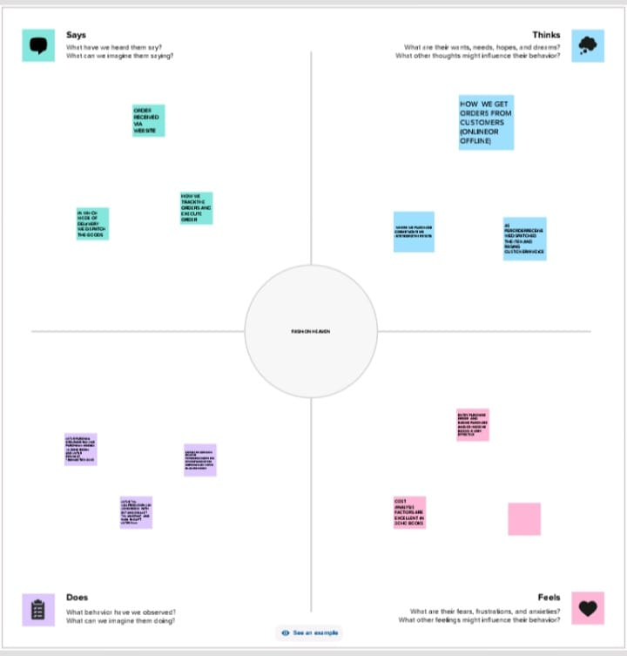

2.2 Ideation & Brainstorming Map

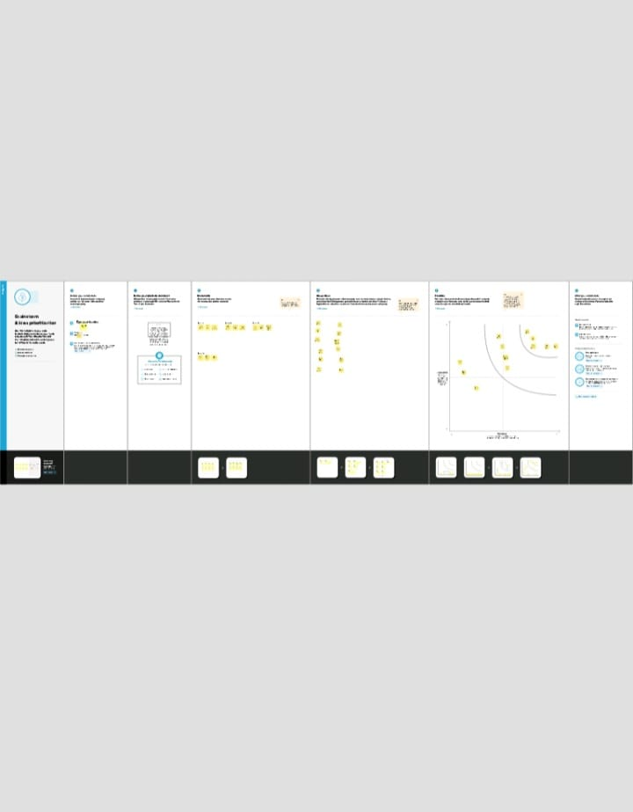

**3. RESULT:**

To Generate the Financial Reports:

1. Profit and loss Account

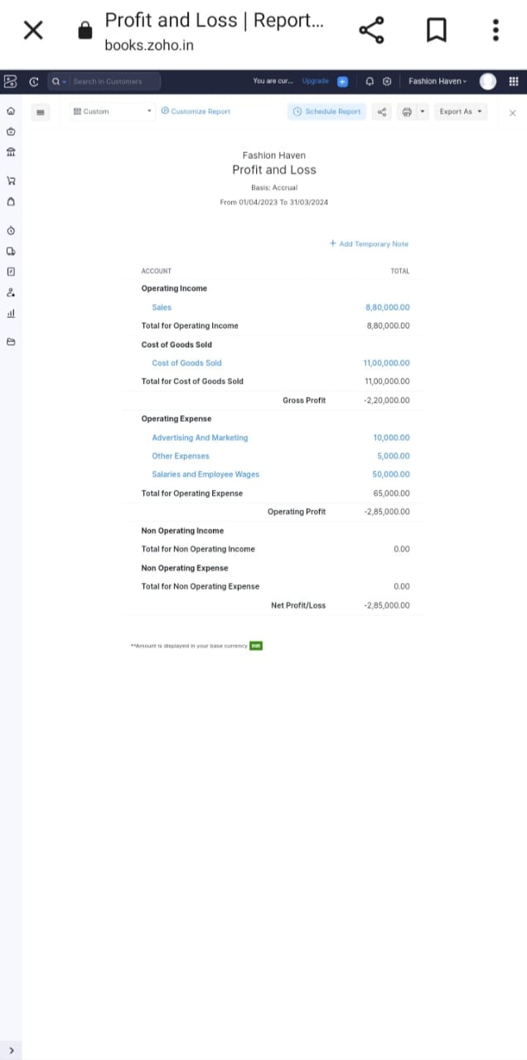

2. Balance Sheet

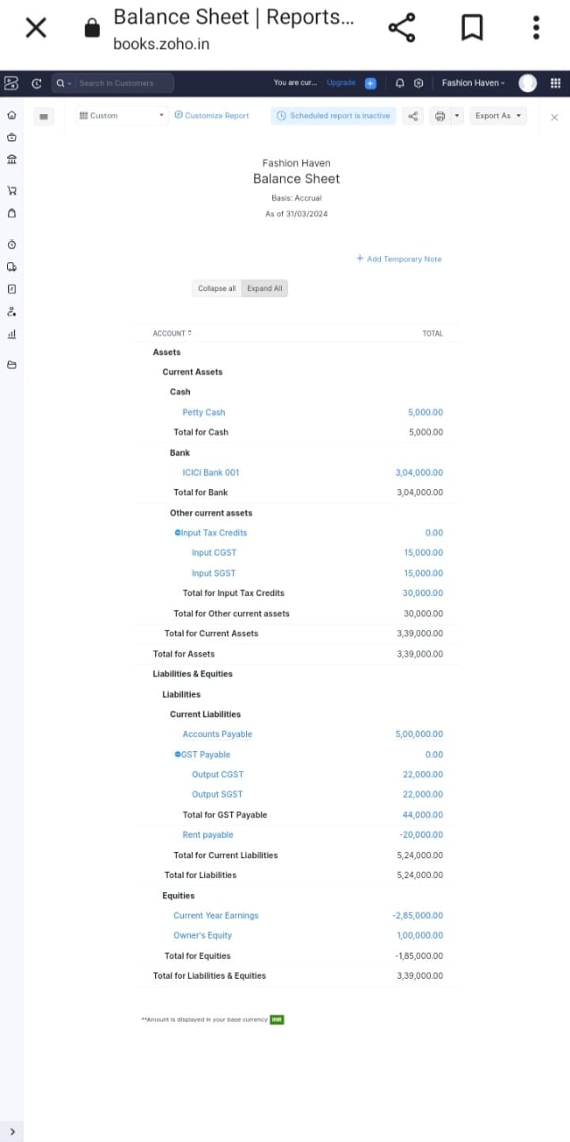

3. GST Reports

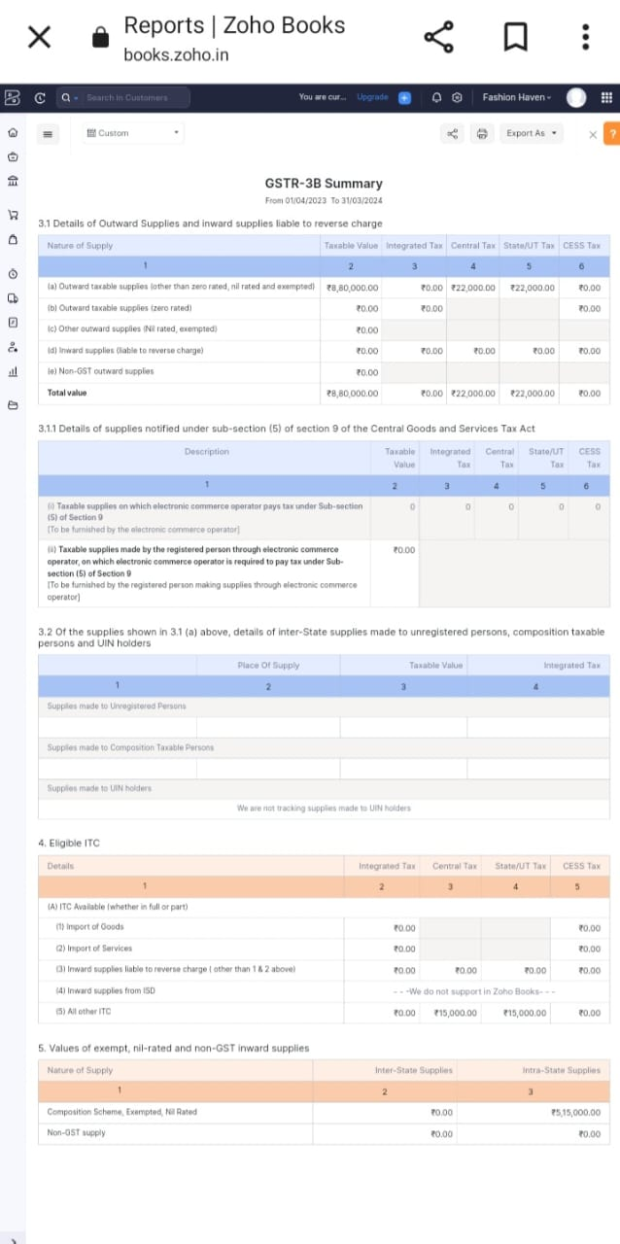

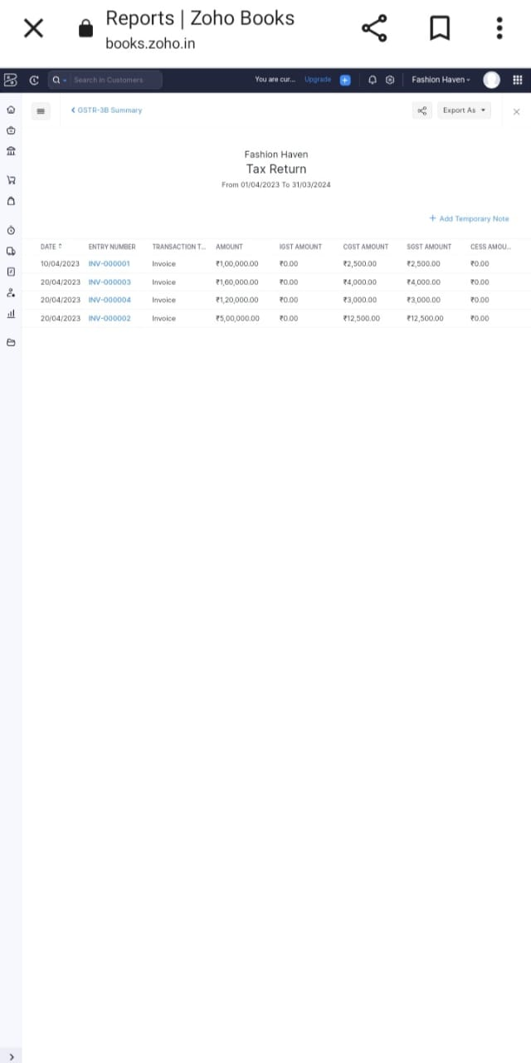

4. Journal Report

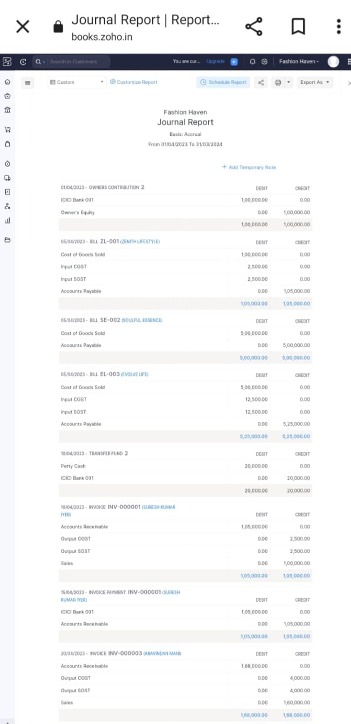

5. Accounts Receivable Summary

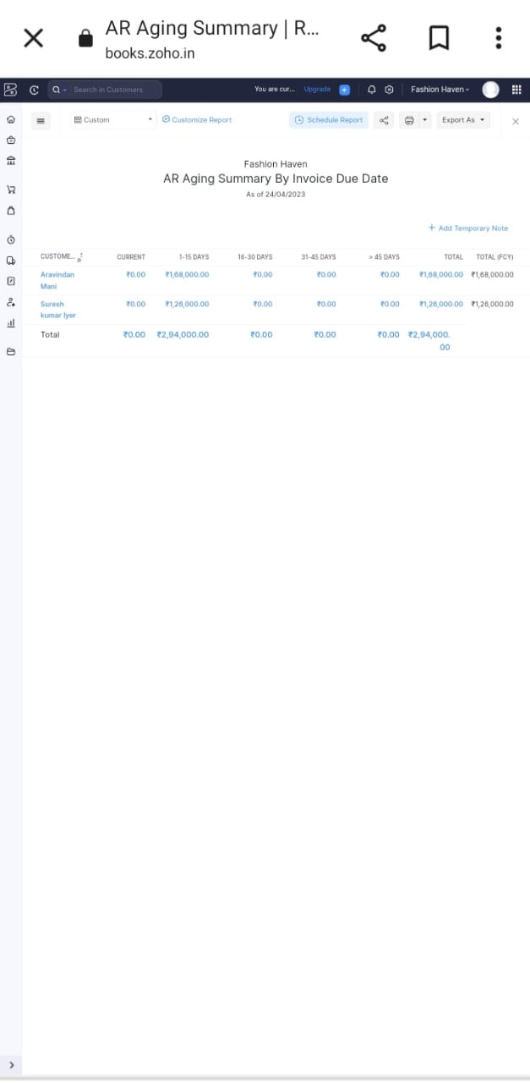

6. Accounts Payable Summary

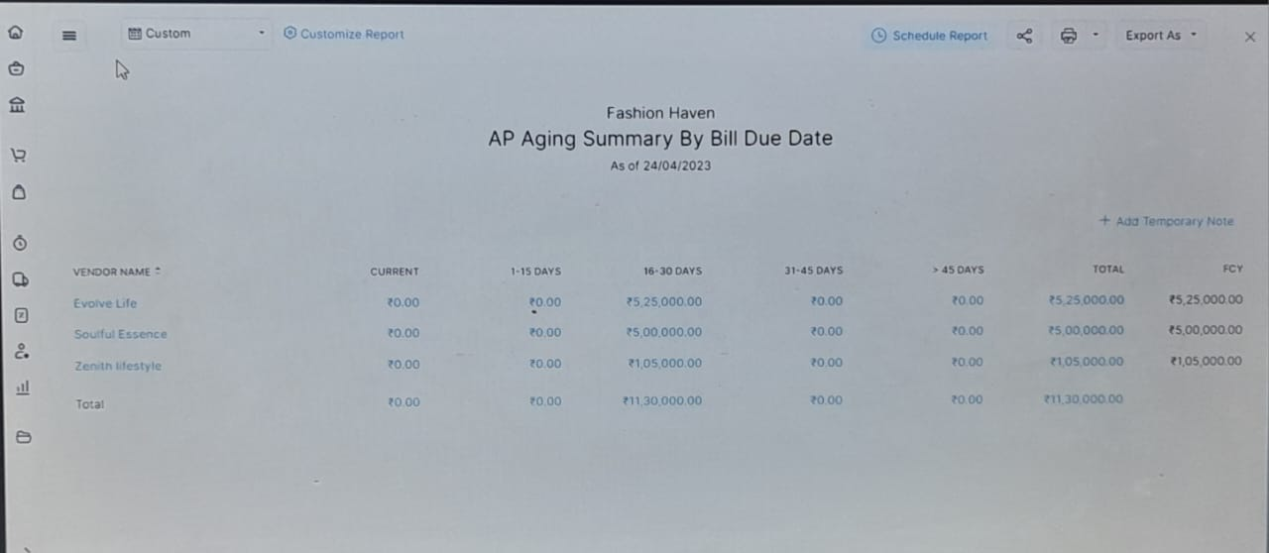

**4. ADVANTAGES & DISADVANTAGES**

List of advantages:

* ZOHO books is Cloud based software, so we access the software in any location.
* Creating of Organization is very easy and user friendly.
* Appearance of software model is very easy to understanding.
* Creation of items, vendors, customers are user friendly while compare with software
* Preparation of purchase order and conversation to purchase Invoice made in a single step.
* Preparation of Sales order and conversation to Sale Invoice made in a single step.
* Default accounting step up is very useful and time saving.
* GST procedure is very easy to enter.
* Getting financial report and tax report in single step.

List of disadvantages:

* ZOHO books is Cloud based software, which need internet and other technical facility.
* In absence of internet facility, the working in ZOHO books is very difficult.
* There is no secure in data of the organization.

**5. APPLICATIONS:**

The ZOHO Books is good software in all type of organization and we get better results instantly. We collect the following data and entered in ZOHO Books in various modules like item creation, Vendor creation, customer creation, preparation of Purchase order, Purchase Invoice, sales order, sale Invoice, making payment to vendors and Expenses, Received amount from Customers.

**Item creation:**

1. T-Shirts Selling price Rs.100/- each

2. Shirts Selling Price Rs.500/- each

3. Joggers Selling Price Rs. 800/- each

4. Hoodies Selling Price Rs.1200/- each

5. Shoes Selling Price Rs.1000/- each

OUTPUT GST @5% is applicable on all the above products, Cost Price of the above products is 50% of Selling Price

**Vendor creation:**

The following are the list of vendors form which the Items are purchased:

1. Zenith Lifestyle (GST registered)

2. Soulful Essence (Non GST)

3. Evolve Life (GST registered)

**Customer creation:**

The below are the list of customers:

1. Suresh Kumar Iyer is a GST registered person.

2. Priya Ranganathan is a GST registered person.

3. Aravindan Mani is not a registered person.

**Preparation of Purchase order, Purchase Invoice:**

1. 05-04-2023 Zenith Lifestyle - T-Shirts – 2000 pcs Rs.50/- each GST @ 5%

2. 05-04-2023 Soulful Essence – Shoes – 1000 pcs Rs.500/- each

3. 05-04-2023 EvolveLife – Shirts 2000pcs Rs.250 each GST @ 5%

**Preparation of sales order, sale Invoice:**

1. 10/04/2023 Suresh Kumar iyer – 1000 pcs of T-Shirts on credit – paid through bank on 25/04/2023

2. 20/04/2023 Priya Ranganathan – 500 pcs Shoes – Paid in cash on 20/04/2023

3. 20-04-2023 Aravindan Mani purchased 200pcs of Joggers.

4. 20-04-2023 Suresh Kumar Iyyar purchased 100 pcs of Hoodies

**Making payment to vendors and Expenses:**

1. Employee salaries Total Rs.50,000/- paid through Bank on 30-04-2023

2. Rent Paid Rs.50,000/- paid through cash on 30-04-2023

3. Advertisement and Marketing expenses Rs.10,000/- paid in cash.

4. Miscellaneous Expenses Rs.5,000/- paid in cash

5. 25-04-2023 Paid to EvolveLife Rs.525000

6. 25-04-2023 Paid to Zenith Lifestyle Rs.105000

**Received amount from Customers:**

1.15-04-2023 Received from Suresh Kumar Iyyer Rs.105000

2. 20-04-2023 Received from Priya Ranganathan Rs.525000

3.25-04-2023 Received from Aravindan Mani Rs.168000

4.25-04-2023 Received from Suresh Kumar Iyyer Rs.126000

**6. CONCLUSION:**

In maintain of Fashion Haven accounts in ZOHO books is very smart in all the aspects of entries. The basic accounting concept is enough for the operating person(Accountant/Data entry operator). This software is applicable for all types of organization. The entry models of software are easily understood and interest to work. Whatever reports we need, it’s already default in the report models. Totally it’s a good and very useful to the entire entrepreneur with low cost for operating financial department.

**7. FUTURE SCOPE:**

The idea for the founders of ZOHO Books is amazing and very clever. This is a great milestone in the field of accounts maintenance. They offer various plane as per the requirement of the proprietors. It’s a good gift to all the entrepreneurs.